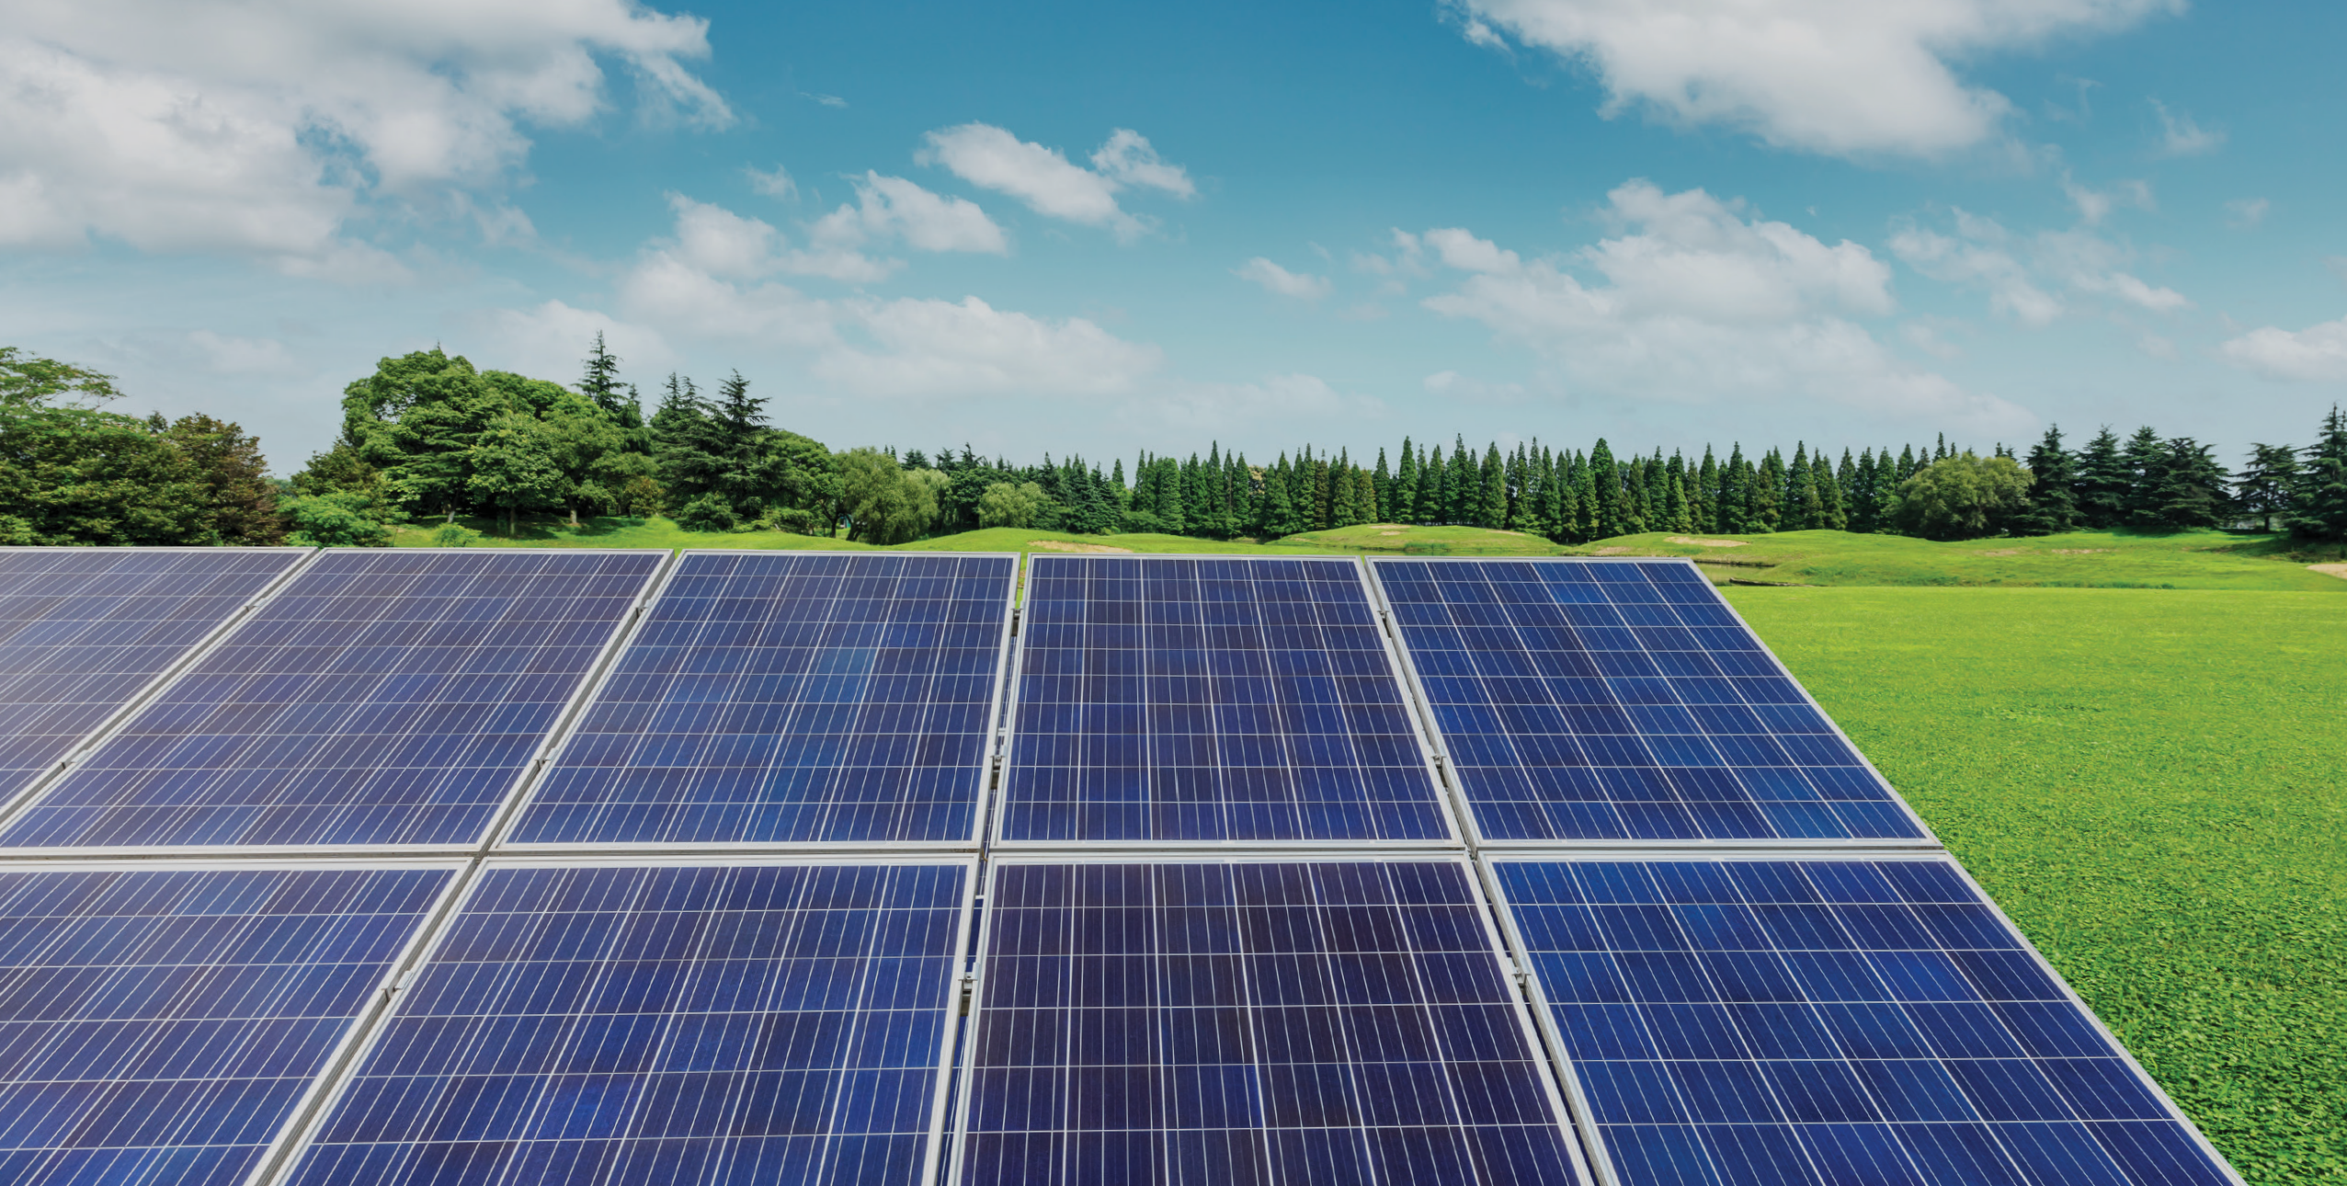

Have your say...
Proposed development of Fetteresso BESS,
Land at The Waters, Kirktown of Fetteresso, Aberdeenshire, AB39 3YR.

Anesco is committed to engaging with the local community and therefore would like to hear your views on our proposals for the Fetteresso Energy Storage development.
- Are you from the local area?
Yes/ No

2. Do you support the increased reliance on renewable energy as part of the UK’s transition to a low-carbon economy?
Yes/ No / Partially/ Not Sure

3. What challenges do you foresee?
Please let us know your comments:

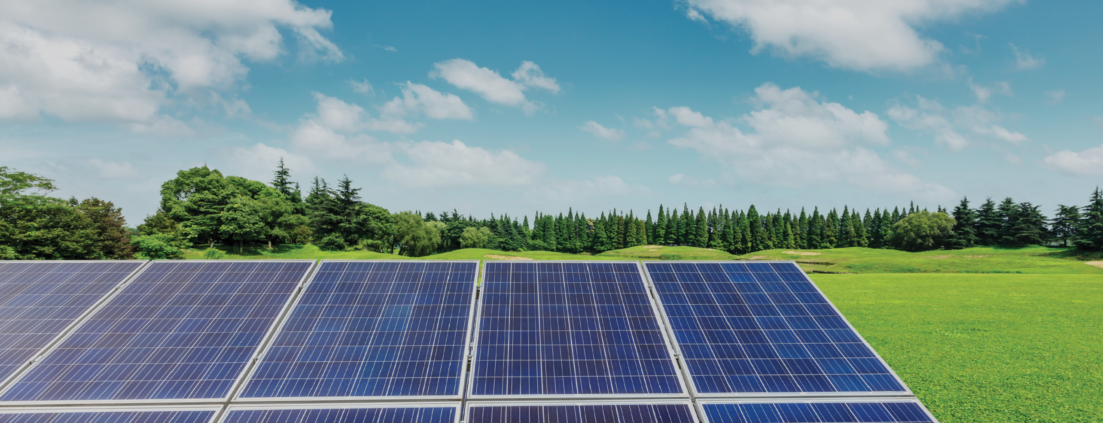

Have your say...
Proposed development of Fetteresso BESS,
Land at The Waters, Kirktown of Fetteresso, Aberdeenshire, AB39 3YR.

4. Please tick/circle the statement that most accurately reflects your views.
I/We fully support the Fetteresso BESS development
I/We broadly support the Fetteresso BESS development
I/We do not support the Fetteresso BESS development
I/We are undecided in the support of Fetteresso BESS development

5. Any other comments?

About you
Please feel free to fill in the following details and where possible, we will seek to keep you informed of any future public consultation events regarding this site.
Title Name
Organisation (if applicable) Address (including postcode)

Email address
Data protection.
Your details will not be passed on to any other private organisation and will be used only in conjunction with this consultation.

Please return this form to us at our consultation events at Fetteresso consultation Address, or alternatively please feel free to email your comments to:
Colin Lavety colin.lavety@stantec.com
Closing date for the return of forms and feedback is 20th March 2025

